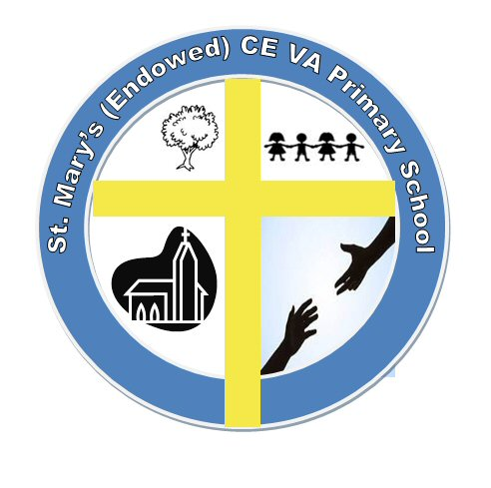
St. Mary’s (Endowed) Church of England VA Primary School

Chapel Road, Roughton,

Norwich, Norfolk, NR11 8AF
Interim Head teacher: Mrs Maureen Burns

 01263 761368
 officesm@lighthousefederation.norfolk.sch.uk

19/07/2023

Dear Parents/Carers,

There will a slight change to the school day from September. To fit in with Government guidelines that require schools to be open for 32.5 hours each week we will adopt the following times. The gates will open at 8.35am and the school day will start at 8.45am. Please could all parents and children enter by the Norwich Road main and not the car park gate.
The school day will finish at the usual time of 3.15pm.

A reminder that all invoices should be paid up to date by the end of the week.

After School clubs will start the week commencing September 11th, further details will be sent out in early September.

Yours sincerely,

Mrs M. Burns
Interim Headteacher

