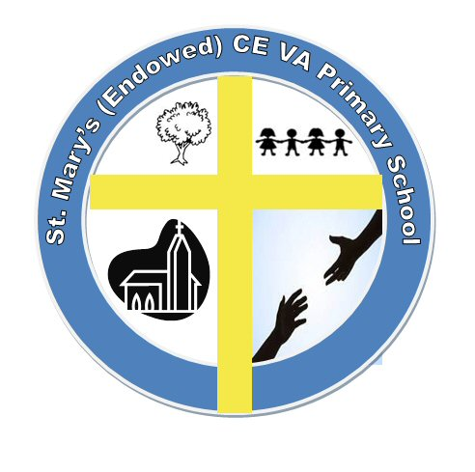
St. Mary’s (Endowed) Church of England VA Primary School

Chapel Road, Roughton,

Norwich, Norfolk, NR11 8AF
Interim Head teacher: Mrs Maureen Burns

 01263 761368
 officesm@lighthousefederation.norfolk.sch.uk

14th July 2023

Dear Parents and Carers

Re: The challenge of social media and school.

There have been a growing number of incidents in school where children have experienced unkind behaviours while using online messaging platforms. Recently a class group chat with several children became unpleasant and many of those participating either behaved unkindly towards others or were the recipient of unkindness or bad language, or both. What began as a friendly exchange between the children became unpleasant. The consequence was that children fell out with each other and also blamed each other for what they had said or done in the chat.
In a conversation with the children about this occurrence they stated that: the group chat often was a place where they argued and fell out;
Often it was later on a night when most children would be expect to be in bed;
Children had their phones by their beds all night;
No adult was looking at what they were messaging their friends in order to keep tabs on what they were doing or saying
Whilst this happened off the school site and outside school hours, the resulting ‘fallouts’ in such situations have implications for relationships within school and a resulting negative impact on teaching and learning and staff spending a disproportionate amount of time trying to manage issues.
If you have concerns that your child might be on the receiving end of hurtful messaging, or playing a part themselves, please talk to us.
The aim at school is to support you and your child, we will:
- Continue, through RSE and assemblies, to educate students of the dangers of inappropriate use of social media platforms and messaging services
- Educate your child on what it means to be a responsible digital citizen
- Continue to support parents and carers with advice on how to tackle inappropriate use either by their own child or others.

Below is a just a short list of online resources offering support and advice on phone usage and digital citizenship. There are many more online where you can seek good advice about phone and internet usage and safety for children.
https://www.internetmatters.org/wp-content/uploads/2019/08/Internet-Matters-Guide-Balancing-Screen-Time-11-14-KeyStage3.pdf
https://www.verywellfamily.com/a-sample-cell-phone-contract-for-parents-and-tweens-3288540
Parents & carers | Childnet
Home Safety Activities (thinkuknow.co.uk)
Homepage - UK Safer Internet Centre
Parent's Guide to Digital Citizenship - The Digital Wellness Lab
Stop Speak Support advice for parents - Internet Matters
I hope that by working together we will keep all our children safe and well and good digital citizens.
Yours sincerely,
Mrs M. Burns

